

**SOFTWARE REQUIREMENT SPECIFICATION (SRS) SIGN-OFF**

**Authorization Memorandum**

This form is to sign-off completion of the Requirement Phase for **CAMPUS MANAGEMENT SOFTWARE AT WORLD SKILL CENTER (WSC).**

World Skill Centre (WSC) acknowledges receipt of the deliverables as part of the Requirement Phase through the submission of this document.

|  |  |
| --- | --- |
| **MODULE NAME** | **Placement Module** |

| **VERSION HISTORY** | | | |
| --- | --- | --- | --- |
| **Version** | **Author** | **Date** | **Changes** |
|  |  |  |  |
|  |  |  |  |

**WSC AUTHORITY NAME AND**  **SIGNATURE**

**SOUL AUTHORITY NAME AND**  **SIGNATURE**

Pages 1 of 21



**Software Requirement Specification (SRS)**

Of

**Placement module**

For Implementation of

**Campus Management Software**

at

**World Skill Center (WSC)**

**Sustainable Outreach And Universal**

**Leadership (SOUL) Limited**

A. Abstract 3

B. Introduction 3

C. Definition, Acronyms and Abbreviations 3

D. Overview of the Document 3

E. Scope of Training and Placement Module 4

F. Placement Process Flow 5

G. Process Flow Description 5

H. List of Screens and their Descriptions 6

I. Placement 7

Placement Company 7

Placement Drive 8

Placement Drive Application 11

Placement Blocked Student 13

Placement Tool 15

Selection Round 16

Selection Round Report 18

Entrepreneurship 19

# Abstract

Software Requirements Gathering is one of the first phases of system development. This phase results in the Software Requirements Specification (SRS) document, which must contain a complete, concise, high-quality description of the system being considered.

# Introduction

The World Skill Center (WSC) is a premier advanced skill training institute established by the Government of Odisha, Skill Development and Technical Education Department, through the Odisha Skill Development Authority (OSDA). The WSC will impart advanced skill training in eight trades from engineering and service sectors. WSC caters primarily to induct the best talent from ITIs and Polytechnics and train them to become globally employable in emerging areas such as "Industry 4.0". WSC is housed in a state-of-the-art, 18-storey, air-conditioned building with nearly half a million square feet of space in the heart of capital city of Bhubaneswar.

With the Implementation of campus management software for WSC the goal is to streamline the operations and functions of the campus by integrating various processes, such as admissions, course registration, academic progress tracking, and financial management, HRMS, Procurement and Inventory management, etc into a unified system. The implementation also aims at providing a user-friendly interface for all stakeholders, making it easier for them to access the necessary information and complete their tasks with ease. The modules to be covered during the implementation of the software includes:

|  |  |
| --- | --- |
| Students Management Modules | Infrastructure Management |
| Academic System | Finance and Accounting System |
| Procurement & Inventory Management | Training and Placement |
| Human Resources Management System | Application Integration |

# Definition, Acronyms and Abbreviations

The following table explains the terms and abbreviations used in the document:

|  |  |
| --- | --- |
| **Abbreviation** | **Description** |
| SRS | Software Requirements Specification |
| SLCM | Student Life Cycle Management |
| R | Rename - When a field is Renamed |
| N | New - When a New field is Added |
| D | Delete - When an Existing field is Deleted |
| NA | Not Applicable |
| TnP | Training and Placement |

# Overview of the Document

This requirement document provides a detailed overview of the functional requirements of a project. It serves as a communication tool between stakeholders, including developers, project managers, and end-users. The purpose of this requirement document is to define and document the project's objectives, scope, and expectations, and to ensure that all stakeholders have a clear understanding of what the project entails.

This document covers all the functional requirements of the Training module of the ERP product. THis module helps in organizing the entire training setup such as Participants Database, Application forms, Participant attendance etc.

# Scope of Training and Placement Module

* Placement
* Candidate Selection
* Round scheduling
* Result declaration
* Drive creation

Following functionalities are covered in this SRS document:

* **Placement company record creation**
* **Placement drive creation**
* **Student shortlisting**
* **Student application**
* **Round Scheduling**
* **Result declaration**

# Placement Process Flow

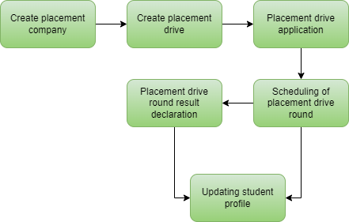

Fig : 1 Placement Process Flow

# Process Flow Description

**Create placement company**

This allows the user to create and maintain records of companies who are interested in offering jobs to the WSC students.

**Create placement drive**

This allows the user to create and maintain records of placement drives for different companies.

**Placement drive application**

This allows the students to apply for a drive that they are eligible for.

**Scheduling of placement drive round**

This allows the user to schedule a round of a placement drive for all the eligible applicants.

**Placement drive round result declaration**

This allows the user to declare the result of a round of a placement drive upon the completion of the round.

**Updating student profile**

The profile of a student will be update with the result of rounds for different placement drives that the student applied for.

# List of Screens and their Descriptions

The following tables lists the pages used in ToT module :

|  |  |  |
| --- | --- | --- |
| **Sl no** | **Screen Name** | **Description** |
|  | Placement Company | This allows the user to create a record and modify any existing record of a company that is offering placements to the WSC students. |
|  | Placement Drive | This allows the user to create a placement drive record and modify any existing placement drive records for a company that is offering placement to the WSC students. |
|  | Placement Drive Application | This allows a WSC student to apply for a placement drive that they are eligible for |
|  | Placement Blocked Student | This screen allows the user to block a student from a placement drive. |
|  | Placement Tool | This allows the user to schedule different rounds of a placement along with declaring the results of |
|  | Selection Round | This screen keeps the records of all the placement drive rounds that have been scheduled and whose results have been declared. |
|  | Selection Round Report | This screen is used by the student to view a report regarding their performance in the different rounds of placement drives. |
|  | Entrepreneurship | This screen allows the user to create and manage records of companies formed by students or alumni of WSC. |

# Placement

Following are the screens used to achieve the functionalities of Placement

### Placement Company

**General Description**

The following table describes overall information about this screen:

|  |  |  |
| --- | --- | --- |
| **Description** | | This screen is used to record the details of a company who has shown interest in offering placements to WSC students. |
| **Navigation** | Home > Academics > Placement & Drives > Placement Company | |
| **Pre-requisites** | NA | |
| **Existing Screen Name** | No Change | |
| **New Screen Name** | Placement Company | |

**Screenshot**

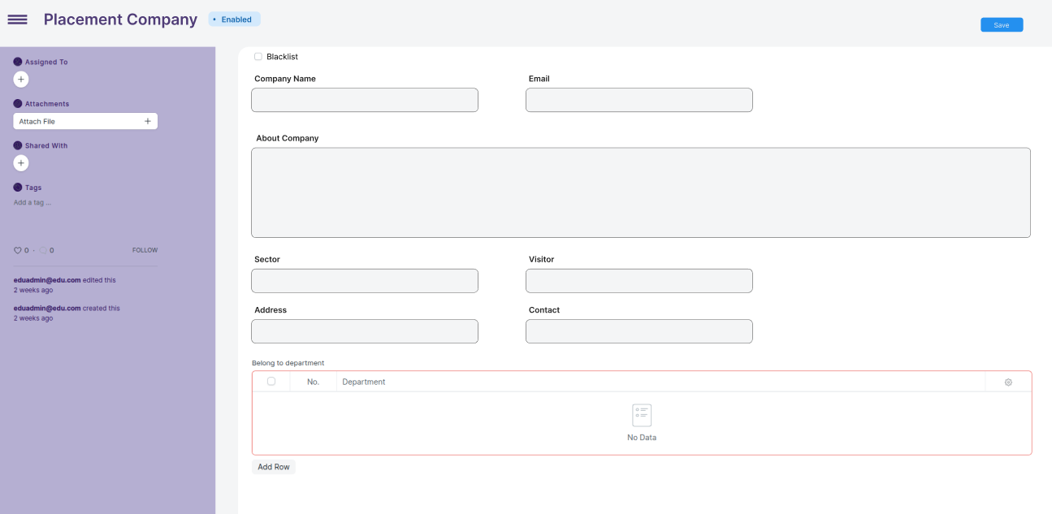

Fig 2: Placement Company Screen

**Field List**

The following table describes the UI fields present in this screen :

|  |  |  |  |  |  |  |
| --- | --- | --- | --- | --- | --- | --- |
| **ID** | **Field Name** | **Field Type** | **Mandatory** | **Validation/ Action** | **Remarks** | **R/N/D** |
| 1 | Blacklist | Checkbox | Yes |  |  |  |
| 2 | Company Name | Data | Yes | User input |  |  |
| 3 | Email | Email | Yes | User input |  |  |
| 4 | About company | Text editor | Yes | User input |  |  |
| 5 | Sector | Link | Yes | Fetched from Sector screen |  |  |
| 6 | Visitor | Select | Yes | Options:   1. Internship 2. Day 0 visitor 3. Day 1 visitor 4. Day 2 visitor 5. One time visitor 6. Normal visitor |  |  |
| 7 | Address | HTML | Yes | User input |  |  |
| 8 | Contact | HTML | Yes | User input |  |  |
| 9 | Department | Table | Yes |  |  |  |
| **Belong to department Table** | | | | | | |
| 10 | Department | Link | Yes | Fetched from Department screen |  |  |

**User: Roles & Permission**

The following table describes the users and their roles and permissions for the screens :

|  |  |  |  |  |  |  |  |  |
| --- | --- | --- | --- | --- | --- | --- | --- | --- |
| **ID** | **Role** | **Read** | **Write** | **Create** | **Delete** | **Submit** | **Cancel** | **Amend** |
| 1 | Training and Placement Administrator | Yes | Yes | Yes | No | NA | NA | NA |

### Placement Drive

**General Description**

The following table describes overall information about this screen:

|  |  |  |
| --- | --- | --- |
| **Description** | | This screen allows the user to create and maintain records of placement drives created for different companies that are offering placements to the WSC students. |
| **Navigation** | Home > Academics > Placement & Drives > Placement Drive | |
| **Pre-requisites** | NA | |
| **Existing Screen Name** | No Change | |
| **New Screen Name** | Placement Drive | |

**Screenshot**

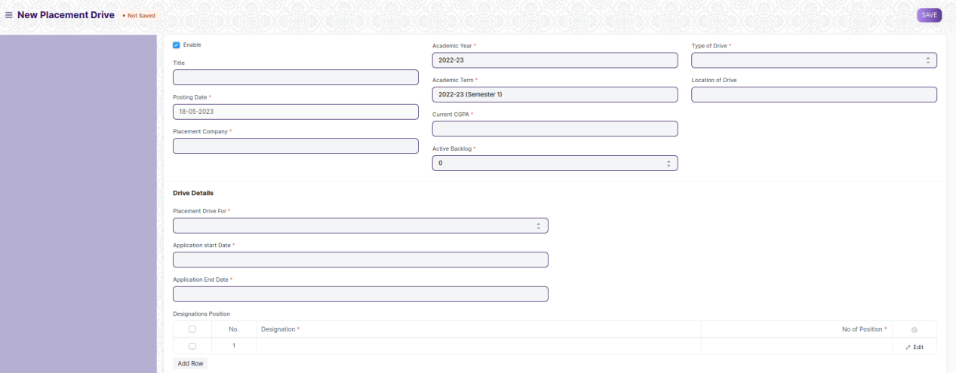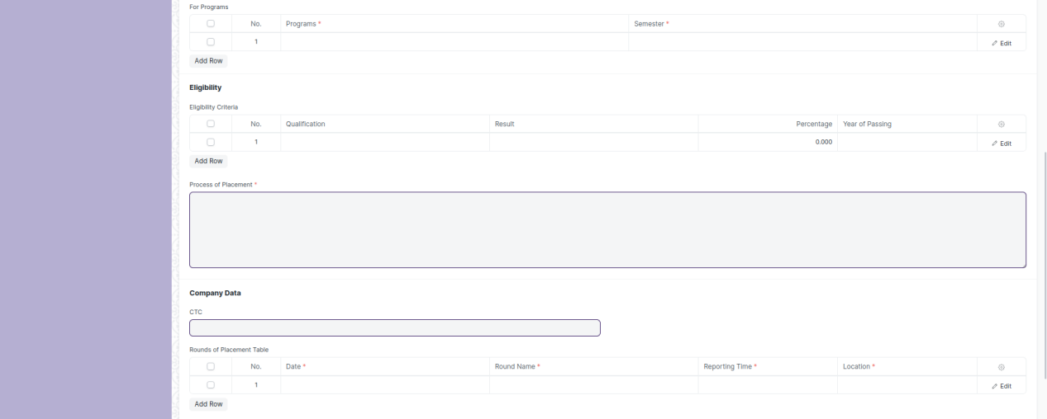



Fig 3 : Placement Drive Screen

**Field List**

The following table describes the UI fields present in this screen :

|  |  |  |  |  |  |  |
| --- | --- | --- | --- | --- | --- | --- |
| **ID** | **Field Name** | **Field Type** | **Mandatory** | **Validation/ Action** | **Remarks** | **R/N/D** |
| 1 | Enable | Checkbox |  |  |  |  |
| 2 | Title | Data |  | User input |  |  |
| 3 | Posting Date | Date | Yes | User input |  |  |
| 4 | Placement Company | Link | Yes | Fetched from Placement Company screen |  |  |
| 5 | Academic Year | Link | Yes | Fetched from Academic Year screen |  |  |
| 6 | Academic Term | Link | Yes | Fetched from Academic Term screen |  |  |
| 7 | Current CGPA | Float | Yes | User input |  |  |
| 8 | Active Backlog | Select | Yes | Options:   1. 0 2. 1 3. 2 4. 3 |  |  |
| 9 | Type of Drive | Select | Yes | Options:   1. IN Campus 2. OFF Campus |  |  |
| 10 | Location of Drive | Link |  | Fetched from Location screen |  |  |
| 11 | For Department | Table |  |  |  |  |
| 12 | Sector of Work | Link | Yes | Fetched from Sector screen |  |  |
| 13 | Placement Drive For | Select | Yes | Options:   1. Fresher 2. Experience 3. Both |  |  |
| 14 | Application Start Date | Date | Yes | User input |  |  |
| 15 | Application End Date | Date | Yes | User input |  |  |
| 16 | Designations Position | Table | Yes |  |  |  |
| 17 | For Programs | Table | Yes |  |  |  |
| 18 | Eligibility Criteria | Table | Yes |  |  |  |
| 19 | Process of Placement | Small Text | Yes | User input |  |  |
| 20 | CTC | Float |  | User input |  |  |
| 21 | Rounds of Placement Table | Table | Yes |  |  |  |
| 22 | Joining Type | Select | Yes | Options:   1. Immediate 2. Non-Immediate |  |  |
| 23 | Type of Job | Select | Yes | Options:   1. Internship 2. Contractual 3. Non-contractual 4. Permanent |  |  |
| 24 | Get Students | Button |  |  |  |  |
| 25 | Eligible Student | Table |  |  |  |  |
| **Designations Positions Table** | | | | | | |
| 17 | Designation | Link | Yes | Fetched from Designation screen |  |  |
| 18 | No of Positions | Data | Yes | User input |  |  |
| **For Programs Table** | | | | | | |
| 19 | Programs | Link | Yes | Fetched from Programs screen |  |  |
| 20 | Semester | Link | Yes | Fetched from Semester screen |  |  |
| **Eligibility Criteria** | | | | | | |
| 21 | Qualification | Select |  | Options:   1. 10th 2. 12th 3. Diploma 4. ITI 5. UG 6. PG |  |  |
| 22 | Result | Select |  | Options:   1. Pass 2. Fail |  |  |
| 23 | Percentage | Float |  | User input |  |  |
| 24 | Year of Passing | Date |  | User input |  |  |
| **Rounds of Placement Table** | | | | | | |
| 25 | Date | Date | Yes | User input |  |  |
| 26 | Round Name | Data | Yes | User input |  |  |
| 27 | Reporting Time | Time | Yes | User input |  |  |
| 28 | Location | Link | Yes | Fetched from Location screen |  |  |
| 29 | Contact Person Name | Data |  | User input |  |  |
| 30 | Contact Person Number | Number |  | User input |  |  |
| 31 | Round Status | Read only |  |  |  |  |

**User: Roles & Permission**

The following table describes the users and their roles and permissions for the screens :

|  |  |  |  |  |  |  |  |  |
| --- | --- | --- | --- | --- | --- | --- | --- | --- |
| **ID** | **Role** | **Read** | **Write** | **Create** | **Delete** | **Submit** | **Cancel** | **Amend** |
| 1 | Training and Placement Administrator | Yes | Yes | Yes | No | Yes | Yes | Yes |
| 2 | Student | Yes | No | No | No | No | No | No |

### Placement Drive Application

**General Description**

The following table describes overall information about this screen:

|  |  |  |
| --- | --- | --- |
| **Description** | | This screen is used to record the details of an application submitted by a student for a placement drive. |
| **Navigation** | Home > Academics > Placement & Drives > Placement Drive Application | |
| **Pre-requisites** | NA | |
| **Existing Screen Name** | No Change | |
| **New Screen Name** | Placement Drive Application | |

**Screenshot**

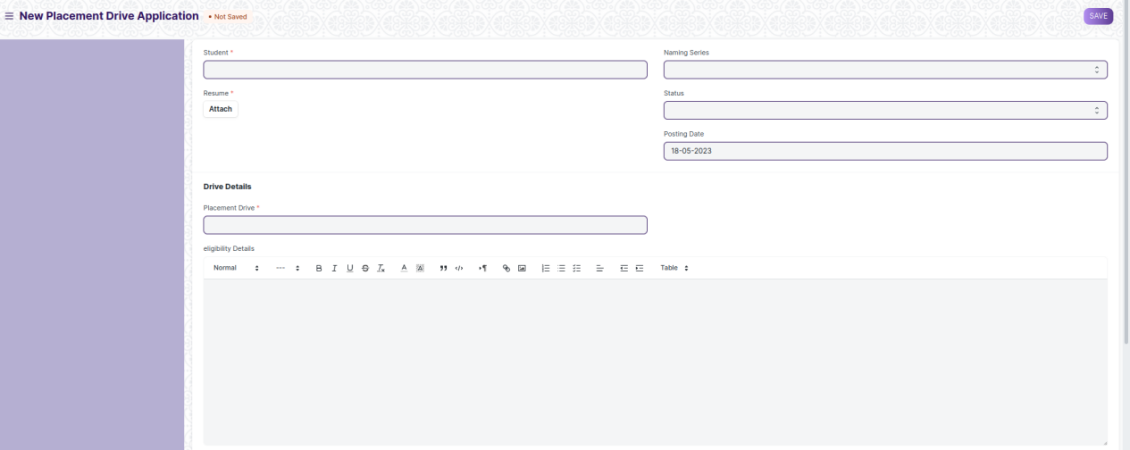



Fig 4: Placement drive application

**Field List**

The following table describes the UI fields present in this screen :

|  |  |  |  |  |  |  |
| --- | --- | --- | --- | --- | --- | --- |
| **ID** | **Field Name** | **Field Type** | **Mandatory** | **Validation/ Action** | **Remarks** | **R/N/D** |
| 1 | Student | Link | Yes | Fetched from Student screen |  |  |
| 2 | Student Name | Data |  | User input |  |  |
| 3 | Roll No | Data |  | User input |  |  |
| 4 | Registration Number | Data |  | User input |  |  |
| 5 | Programs | Link |  | Fetched from Programs screen |  |  |
| 6 | Current Semester | Link |  | Fetched from Program screen |  |  |
| 7 | Resume | Attach | Yes |  |  |  |
| 8 | Naming Series | Select |  |  |  |  |
| 9 | Status | Select |  |  |  |  |
| 10 | Block Student | Check |  |  |  |  |
| 11 | Posting Date | Date |  | User input |  |  |
| 13 | Placement Drive | Link | Yes | Fetched from Placement Drive screen |  |  |
| 14 | Placement Company | Data |  | User input |  |  |
| 15 | Eligibility Details | Text Editor |  | User input |  |  |
| 16 | Educational Details | Table |  |  |  |  |
| **Educational Details Table** | | | | | | |
| 17 | Qualification |  |  | Options:   1. 10th 2. 12th 3. UG 4. PG |  |  |
| 18 | Institute | Data |  | User input |  |  |
| 19 | Board | Data |  | User input |  |  |
| 20 | Percentage | Read Only |  |  |  |  |
| 21 | Year of Completion | Data |  | User input |  |  |

**User: Roles & Permission**

The following table describes the users and their roles and permissions for the screens :

|  |  |  |  |  |  |  |  |  |
| --- | --- | --- | --- | --- | --- | --- | --- | --- |
| **ID** | **Role** | **Read** | **Write** | **Create** | **Delete** | **Submit** | **Cancel** | **Amend** |
| 1 | Training and Placement Administrator | Yes | Yes | Yes | No | Yes | Yes | Yes |
| 2 | Student | Yes | Yes | Yes | No | Yes | No | No |

### Placement Blocked Student

**General Description**

The following table describes overall information about this screen:

|  |  |  |
| --- | --- | --- |
| **Description** | | This screen is used to block students from a placement drive. |
| **Navigation** | Home > Academics > Placement & Drives > Placement Blocked Student | |
| **Pre-requisites** | NA | |
| **Existing Screen Name** | No Change | |
| **New Screen Name** | Placement Blocked Student | |

**Screenshot**

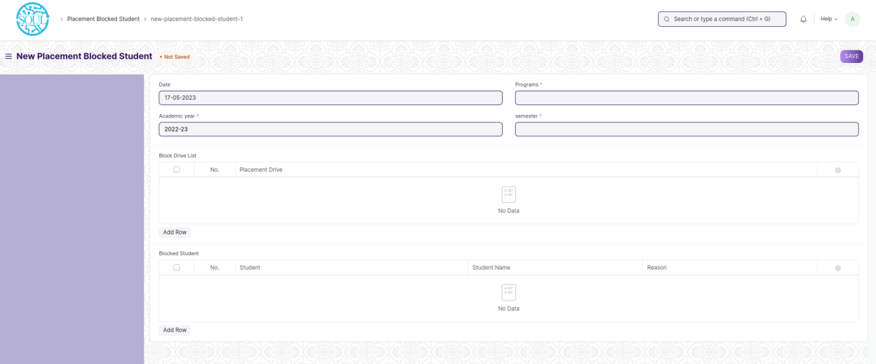

Fig 5: Placement Blocked Student

**Field List**

The following table describes the UI fields present in this screen :

|  |  |  |  |  |  |  |
| --- | --- | --- | --- | --- | --- | --- |
| **ID** | **Field Name** | **Field Type** | **Mandatory** | **Validation/ Action** | **Remarks** | **R/N/D** |
| 1 | Date | Date |  | User input |  |  |
| 2 | Programs | Link | Yes | Fetched from Programs screen |  |  |
| 3 | Academic Year | Link | Yes | Fetched from Academic Year screen |  |  |
| 4 | Semester | Link | Yes | Fetched from Program screen |  |  |
| 5 | Block Drive List | Table |  |  |  |  |
| 6 | Blocked Student | Table |  |  |  |  |
| **Block drive list** | | | | | | |
| 7 | Placement Drive | Link |  | Fetched from Placement Drive screen |  |  |
| **Blocked Student Table** | | | | | | |
| 8 | Student | Link |  | Fetched from Student screen |  |  |
| 9 | Student Name | Data |  |  |  |  |
| 10 | Reason | Data |  | User input |  |  |

**User: Roles & Permission**

The following table describes the users and their roles and permissions for the screens :

|  |  |  |  |  |  |  |  |  |
| --- | --- | --- | --- | --- | --- | --- | --- | --- |
| **ID** | **Role** | **Read** | **Write** | **Create** | **Delete** | **Submit** | **Cancel** | **Amend** |
| 1 | Training and Placement Administrator | Yes | Yes | Yes | No | NA | NA | NA |

### Placement Tool

**General Description**

The following table describes overall information about this screen:

|  |  |  |
| --- | --- | --- |
| **Description** | | This tool is used for the scheduling and result declaration of different rounds of a placement drive. |
| **Navigation** | Home > Academics > Placement & Drives > Placement Tool | |
| **Pre-requisites** | NA | |
| **Existing Screen Name** | No Change | |
| **New Screen Name** | Placement Tool | |

**Screenshot**

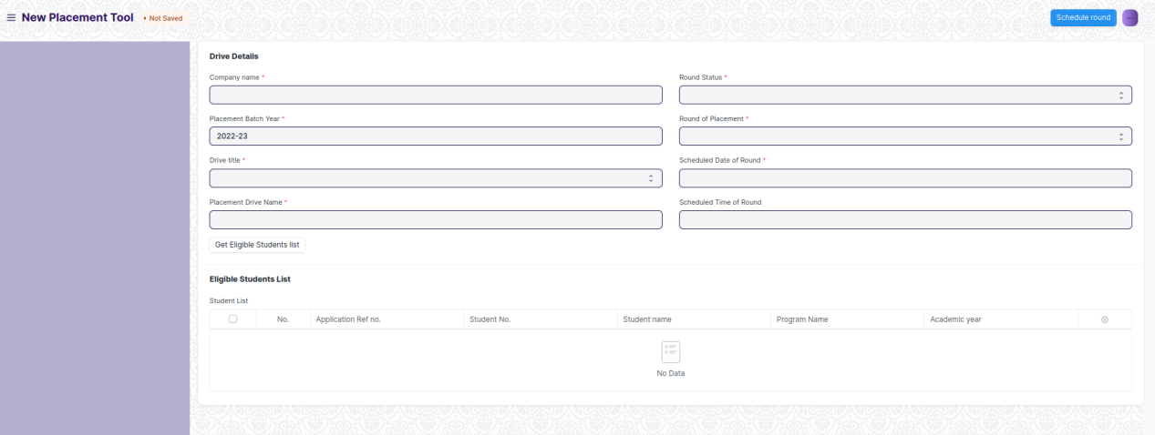

Fig 6: Placement Tool Screen

**Field List**

The following table describes the UI fields present in this screen :

|  |  |  |  |  |  |  |
| --- | --- | --- | --- | --- | --- | --- |
| **ID** | **Field Name** | **Field Type** | **Mandatory** | **Validation/ Action** | **Remarks** | **R/N/D** |
| 1 | Company Name | Link |  | Fetched from Placement Company screen |  |  |
| 2 | Placement Batch Year | Link |  | Fetched from Academic Year screen |  |  |
| 3 | Drive Title | Select |  |  |  |  |
| 4 | Placement Drive Name | Link |  | Fetched from Placement Drive screen |  |  |
| 5 | Round Status | Select |  | Options:   1. Scheduling Of Round 2. Round Result Declaration |  |  |
| 6 | Round of Placement | Select |  |  |  |  |
| 7 | Scheduled Date of Round | Date |  | User input |  |  |
| 8 | Scheduled Time of Round | Time |  | User input |  |  |
| 9 | Get Eligible Students List | Button |  |  |  |  |
| **Eligible Students List Table** | | | | | | |
| 10 | Application Ref no. | Data |  | User input |  |  |
| 11 | Student No. | Data |  | User input |  |  |
| 12 | Student Name | Data |  | User input |  |  |
| 13 | Program Name | Data |  | User input |  |  |
| 14 | Academic Year | Data |  | User input |  |  |

**User: Roles & Permission**

The following table describes the users and their roles and permissions for the screens :

|  |  |  |  |  |  |  |  |  |
| --- | --- | --- | --- | --- | --- | --- | --- | --- |
| **ID** | **Role** | **Read** | **Write** | **Create** | **Delete** | **Submit** | **Cancel** | **Amend** |
| 1 | Training and Placement Administrator | Yes | Yes | Yes | No | NA | NA | NA |

### Selection Round

**General Description**

The following table describes overall information about this screen:

|  |  |  |
| --- | --- | --- |
| **Description** | | This screen is used to manually enter records of students for placement drives. |
| **Navigation** | Home > Academics > Placement & Drives > Selection Round | |
| **Pre-requisites** | NA | |
| **Existing Screen Name** | No Change | |
| **New Screen Name** | Selection Round | |

**Screenshot**

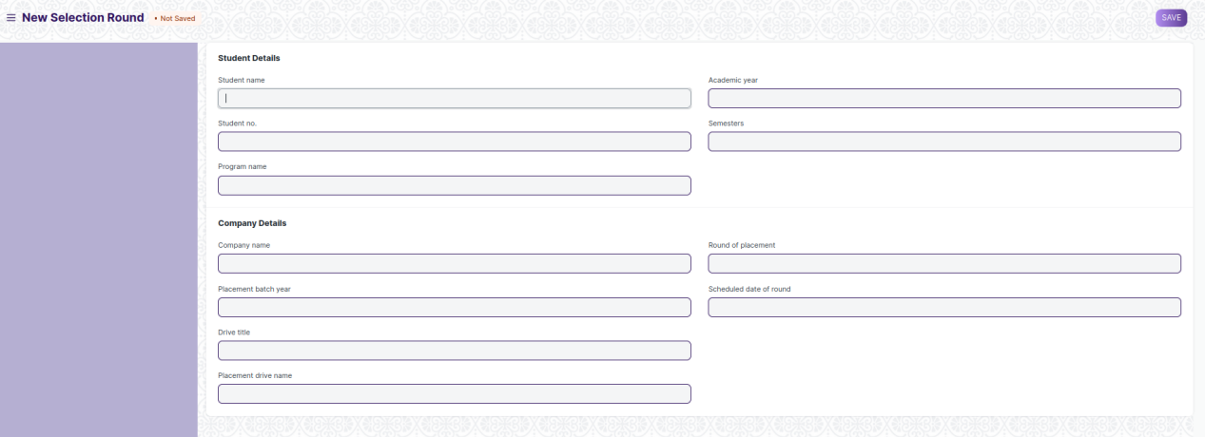

Fig 7 : Selection Round

**Field List**

The following table describes the UI fields present in this screen :

|  |  |  |  |  |  |  |
| --- | --- | --- | --- | --- | --- | --- |
| **ID** | **Field Name** | **Field Type** | **Mandatory** | **Validation/ Action** | **Remarks** | **R/N/D** |
| 1 | Student Name | Data |  | User input |  |  |
| 2 | Student No. | Data |  | User input |  |  |
| 3 | Program Name | Data |  | User input |  |  |
| 4 | Academic Year | Data |  | User input |  |  |
| 5 | Semesters | Data |  | User input |  |  |
| 6 | Company Name | Data |  | User input |  |  |
| 7 | Placement Batch Year | Data |  | User input |  |  |
| 8 | Drive Title | Data |  | User input |  |  |
| 9 | Placement Drive Name | Data |  | User input |  |  |
| 10 | Round of Placement | Data |  | User input |  |  |
| 11 | Scheduled date of round | Data |  | User input |  |  |

**User: Roles & Permission**

The following table describes the users and their roles and permissions for the screens :

|  |  |  |  |  |  |  |  |  |
| --- | --- | --- | --- | --- | --- | --- | --- | --- |
| **ID** | **Role** | **Read** | **Write** | **Create** | **Delete** | **Submit** | **Cancel** | **Amend** |
| 1 | Training and Placement Administrator | Yes | Yes | Yes | No | Yes | Yes | Yes |
| 2 | Student | Yes | No | No | No | No | No | No |

### Selection Round Report

**General Description**

The following table describes overall information about this screen:

|  |  |  |
| --- | --- | --- |
| **Description** | | This screen is used to view the placement round results of students. |
| **Navigation** | Home > Academics > Placement & Drives > Selection Round | |
| **Pre-requisites** | NA | |
| **Existing Screen Name** | No Change | |
| **New Screen Name** | Selection Round | |

**Screenshot**

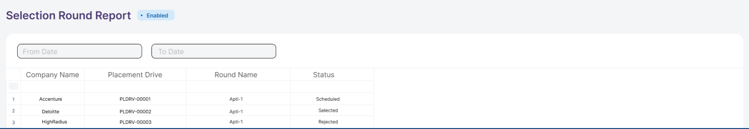

Fig 8 : Selection Round Report

**Field List**

The following table describes the UI fields present in this screen :

|  |  |  |  |  |  |  |
| --- | --- | --- | --- | --- | --- | --- |
| **ID** | **Field Name** | **Field Type** | **Mandatory** | **Validation/ Action** | **Remarks** | **R/N/D** |
| 1 | From date | Date field |  | User Input |  |  |
| 2 | To date | Date field |  | User Input |  |  |

**Actions**

User will enter the search fields such as : From date and To date. Based on these inputs, the report will be shown.

**Report Fields**

|  |  |  |
| --- | --- | --- |
| **ID** | **Column Name** | **Description** |
|  | Company Name | It shows the name of the company |
|  | Placement Drive | It shows the name of the placement drive |
|  | Round Name | It shows the last or upcoming round name of the associated placement drive |
|  | Status | It shows the status of the round |

**User: Roles & Permission**

The following table describes the users and their roles and permissions for the screens :

|  |  |  |  |  |  |  |  |  |
| --- | --- | --- | --- | --- | --- | --- | --- | --- |
| **ID** | **Role** | **Read** | **Write** | **Create** | **Delete** | **Submit** | **Cancel** | **Amend** |
| 1 | Training and Placement Administrator | Yes | Yes | Yes | No | Yes | Yes | Yes |
| 2 | Student | Yes | No | No | No | No | No | No |

### Entrepreneurship

**General Description**

The following table describes overall information about this screen:

|  |  |  |
| --- | --- | --- |
| **Description** | | This screen is used to create and maintain records of companies that have been started by WSC students. |
| **Navigation** | Home > Academics > Placement & Drives > Entrepreneurship | |
| **Pre-requisites** | NA | |
| **Existing Screen Name** | No Change | |
| **New Screen Name** | Entrepreneurship | |

**Screenshot**

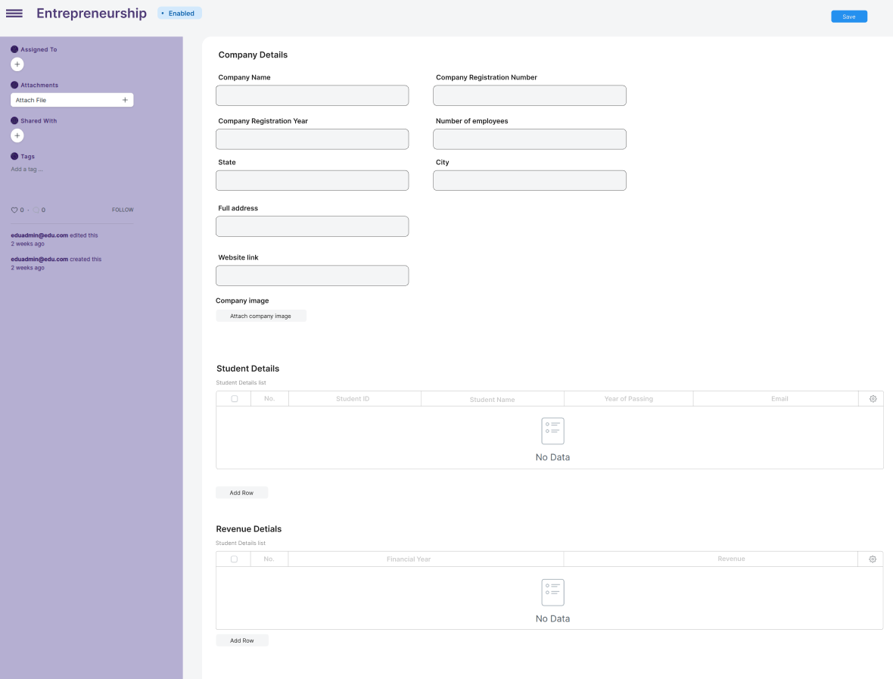

Fig 9 : Entrepreneurship Screen

**Field List**

The following table describes the UI fields present in this screen :

|  |  |  |  |  |  |  |
| --- | --- | --- | --- | --- | --- | --- |
| **ID** | **Field Name** | **Field Type** | **Mandatory** | **Validation/ Action** | **Remarks** | **R/N/D** |
| 1 | Company Name | Data |  | User input |  |  |
| 2 | Company Registration Number | Data |  | User input |  |  |
| 3 | Company Registration Year | Date |  | User input |  |  |
| 4 | Number of employees | Int |  | User input |  |  |
| 5 | State | Data |  | User input |  |  |
| 6 | City | Data |  | User input |  |  |
| 7 | Full address | Data |  | User input |  |  |
| 8 | Website link | Data |  | User input |  |  |
| **Student Details List Table** | | | | | | |
| 9 | Student ID | Data |  | User input |  |  |
| 10 | Student Name | Data |  | User input |  |  |
| 11 | Year of Passing | Date |  | User input |  |  |
| 12 | Email | Email |  | User input |  |  |
| **Revenue Details Table** | | | | | | |
| 13 | Financial Year | Date |  | User input |  |  |
| 14 | Revenue | Float |  | User input |  |  |

**User: Roles & Permission**

The following table describes the users and their roles and permissions for the screens :

|  |  |  |  |  |  |  |  |  |
| --- | --- | --- | --- | --- | --- | --- | --- | --- |
| **ID** | **Role** | **Read** | **Write** | **Create** | **Delete** | **Submit** | **Cancel** | **Amend** |
| 1 | Training and Placement Administrator | Yes | Yes | Yes | No | Yes | Yes | Yes |